The testpoints,source data.

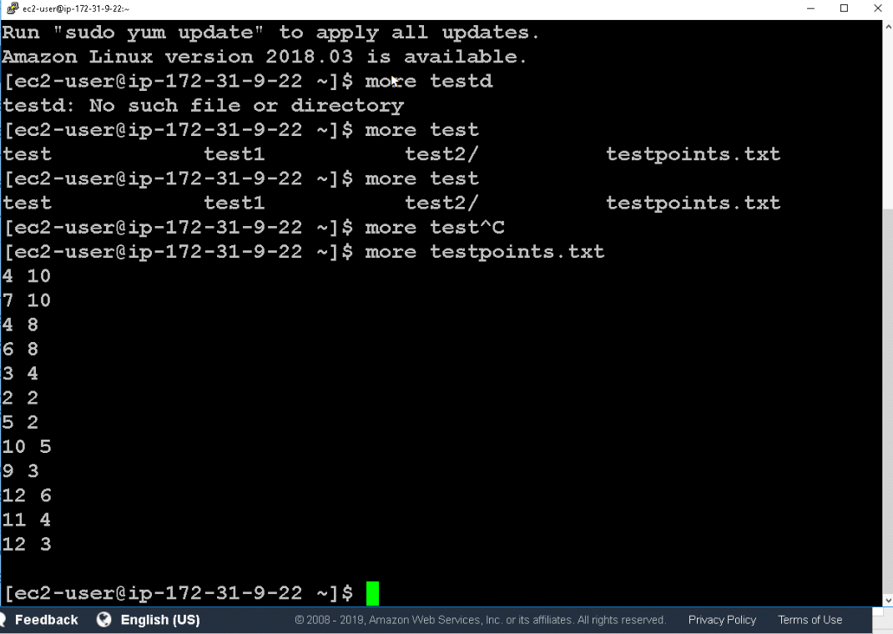

Example command

hadoop jar hadoop-streaming-2.6.4.jar -input /data/sampleData2.txt -file centers.txt -mapper kmeansmapper.py -file kmeansmapper.py -reducer kmeanreducer.py -file kmeansreducer.py -file centers.txt -output /data/kmeans1

Euclidean distance

<https://www.w3resource.com/python-exercises/math/python-math-exercise-79.php>